**TITLE OF LAB: (INTRODUCTION TO SIMULINK IN MATLAB)**

**LAB # 12**



**Spring 2022**

**CSE301L Signals & Systems Lab**

Submitted by: **Safi Ullah Khan**

Registration No. **20PWCSE1943**

Class Section: **B**

“On my honor, as student of University of Engineering and Technology, I have neither given nor received unauthorized assistance on this academic work.”

Student Signature: ______________

Submitted to:

**Engr. Durr-e-Nayab**

Day, Date (e.g Monday, June 20th, 2022)

**Department of Computer Systems Engineering**

**University of Engineering and Technology, Peshawar**

**OBJECTIVES OF THE LAB**

**------------------------------------------------------------------------------------------------------------**

This lab aims at the understanding and introduction to Simulink, an extension to Matlab.

**------------------------------------------------------------------------------------------------------------**

**What is Simulink?**

* Simulink is an extension to Matlab. In Simulink, you build block diagram models of dynamic systems instead of text code. It is easy to model complex nonlinear systems. Simulink can model both continuous and discrete-time components.

**---------------------------TASK ---------------------------**

* Design any signals and systems example in Simulink.
* Let I take a half wave rectifier.

**HALF WAVE RECTIFER:**

* Circuit Diagram of Half Wave Rectifier:

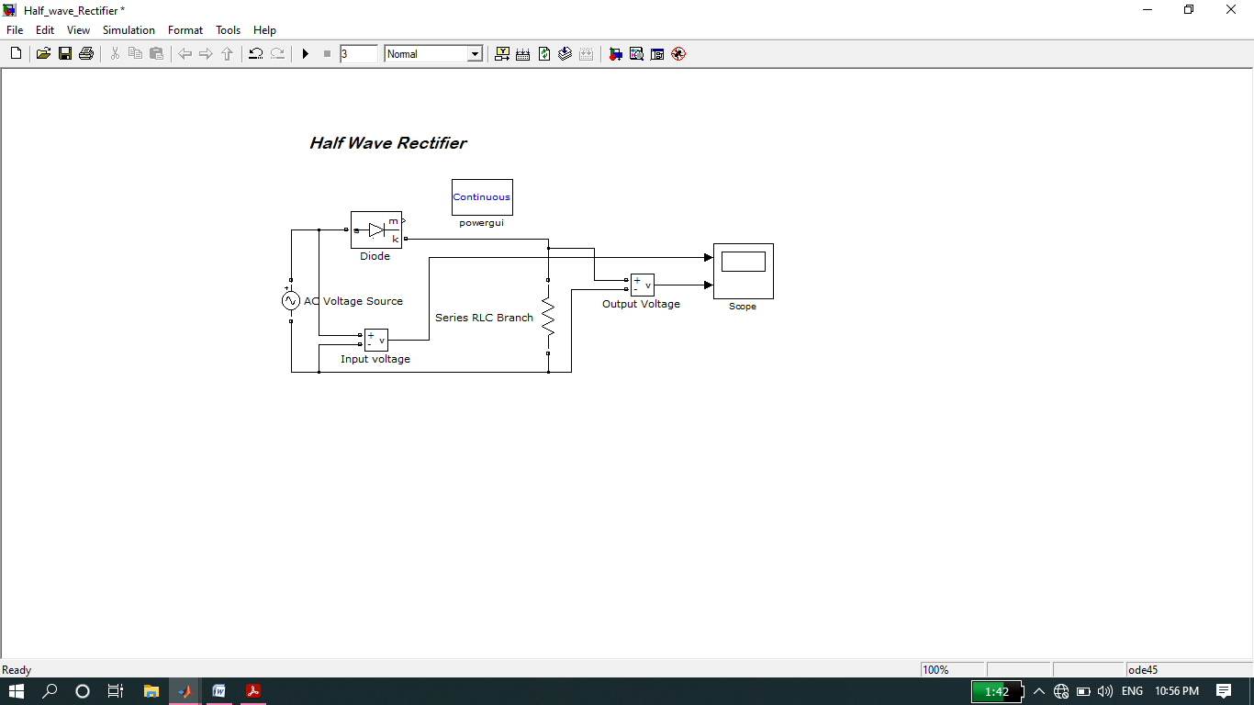

**Graphically Representation:**

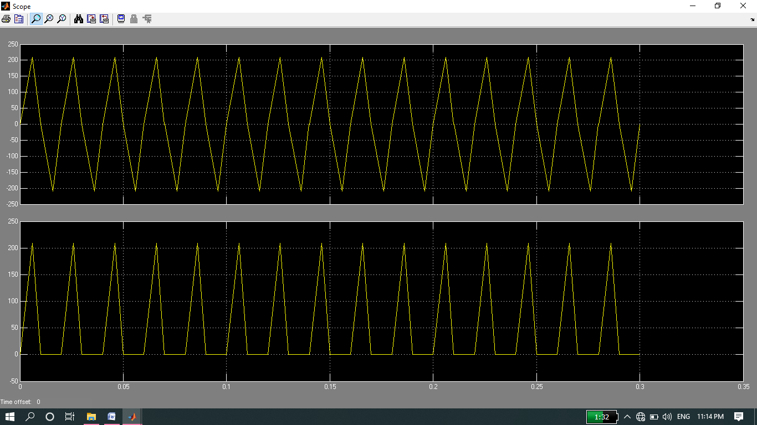

**Now the Implementation of above Circuit Diagram through Coding in Matlab:**

* **Screenshot of Input:**

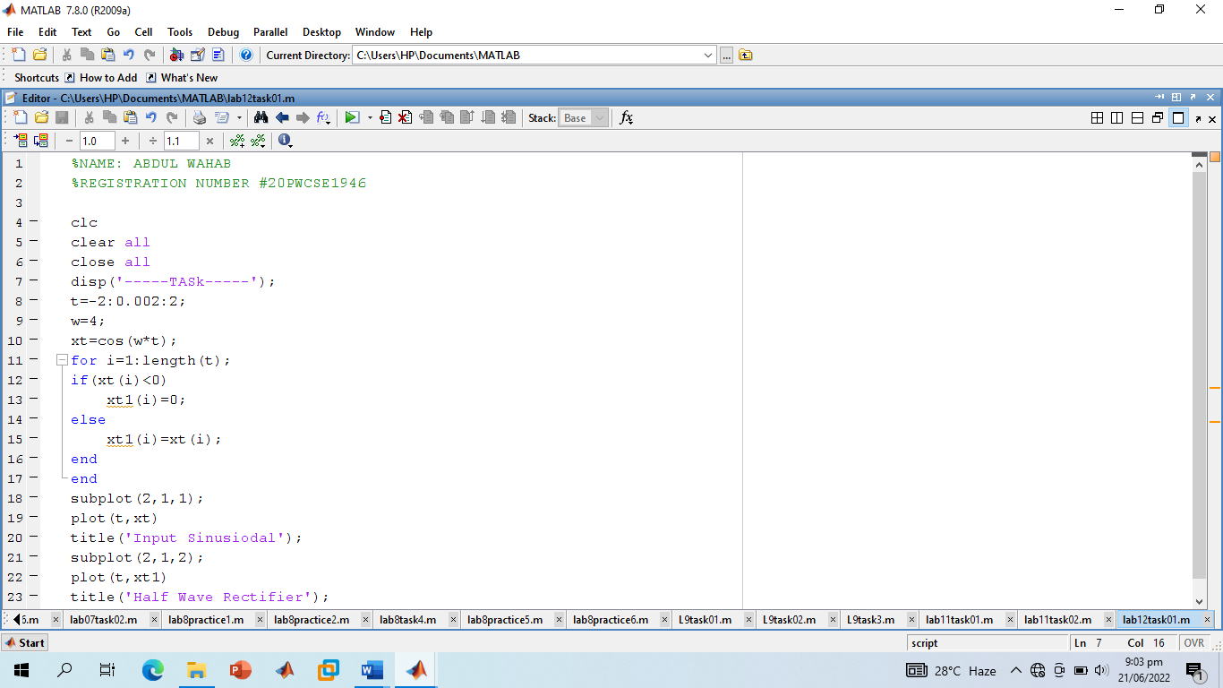

* **Screenshot of Output:**

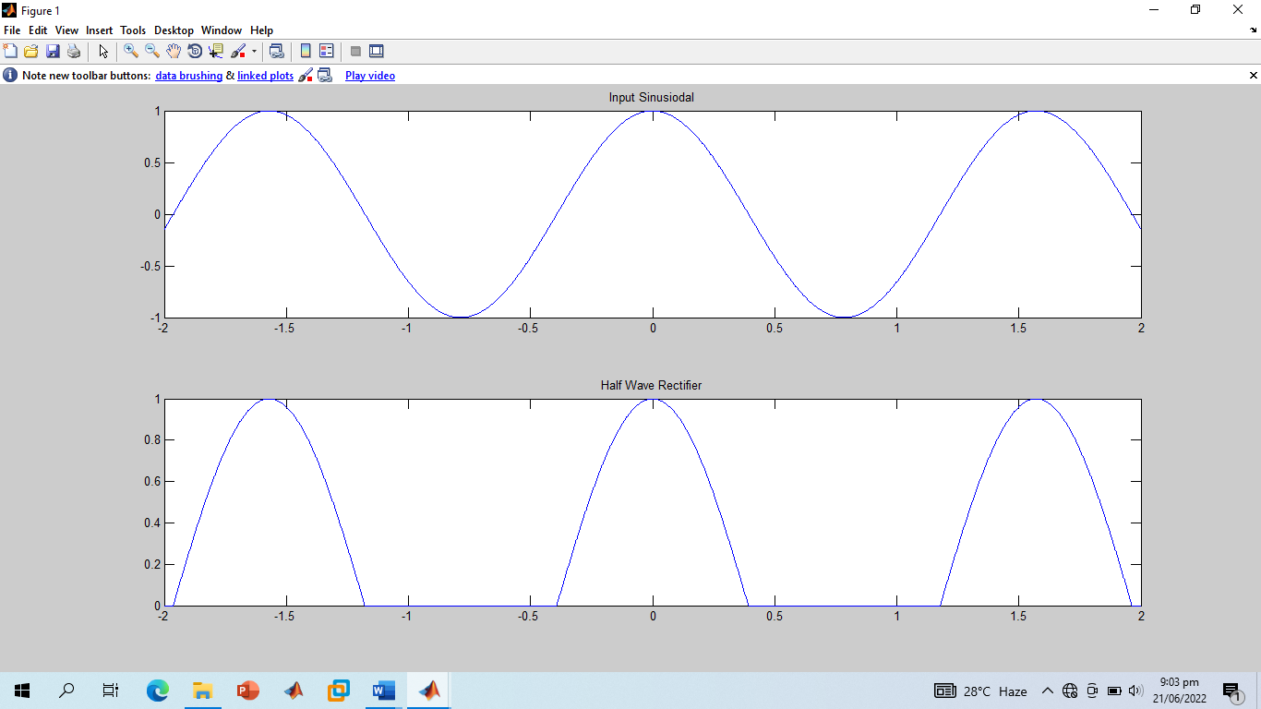

**-----------------------------------THE END-----------------------------------**